Domayne’s Wheel Balanced Sofa

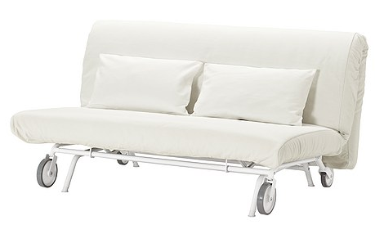

|  |
| --- |
| **DESCRIPTION** |
| Wheel Sofa produced by Domayne’s Sofa, presents a hand stitched very comfortable movable sofa. The extra-wheels make it easy to attach with any bed move it around the place, stable legs comes down with a lock so that wheel does not slip off. Available in White bulky form and hand stitched cloth, the form filled cloth with thick leather add comfort and class to the any room. |

|  |  |  |
| --- | --- | --- |
| **Price** | **1300$** | |
| **Dimensions** | **H** x **W** x **L** | **34in x 31in x 54in** |
| **Features** | **After a back aching day you can relax and fix your back and enjoy our comfort level.** | |
| **Finished** | **Smooth Running Wheels** | |
| **Available in** | **White and Black** | |